Joshua Williamson

**Module 5-2**

**Why would you want to use a CA for security**?

A Certificate Authority (CA) provides a trusted way to confirm the identity of a website or individual. By validating the information in a certificate signing request and signing the certificate with its own private key, the CA ensures that users can trust the connection. This prevents impersonation and gives assurance that communications are with the legitimate entity, not an attacker.

**What are the advantages of using a CA?**

The main benefit is trust. CAs are widely recognized as reliable third parties, a CA-issued certificate shows users that your site is authentic and secure. This builds confidence for the end user, which is reinforced by visible indicators like the HTTPS padlock. Compared to self-signed certificates, which offer no outside validation, CA-signed certificates are far more trustworthy and effective for public networks.

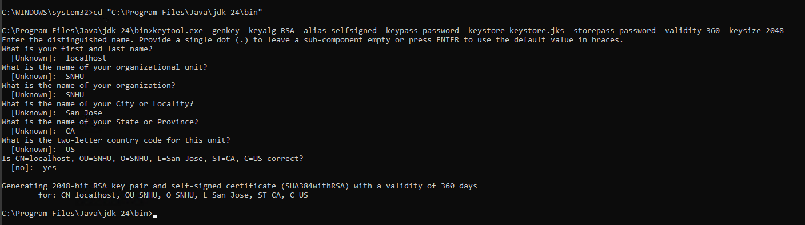

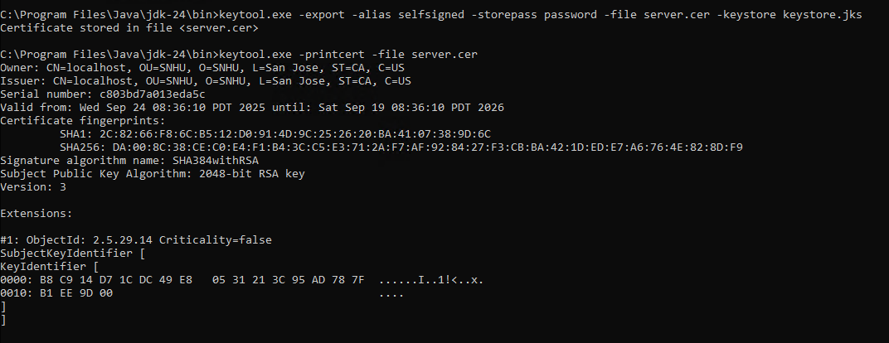

**Resources**

**Cloudflare - What is an SSL certificate?**

https://www.cloudflare.com/learning/ssl/what-is-an-ssl-certificate

**DigiCert (2022) What is a certificate authority (CA)?**

https://www.digicert.com/what-is-an-ssl-certificate